February 2025 Trip Report
Prepared by Robert Cely
The Boma Assistance Group/Trinity South Sudan Ministry sent a team of five to Pochalla, South Sudan from February 17 to 21, 2025.
Objectives
The primary goals for the trip were:
- Meet with the church leaders of the Presbyterian Church of South Sudan (PCoSS).
- Distribute Talking Bibles (audio Bibles) in the local language.
- Distribute reading glasses and sunglasses.
- Assess the status and possibly finish installation of solar water system in Pochalla.
- Evaluate the farming methods and techniques, including dry season watering of crops.
- Donate laptop computers for the computer lab at a local theological college.
Gracious Hosts
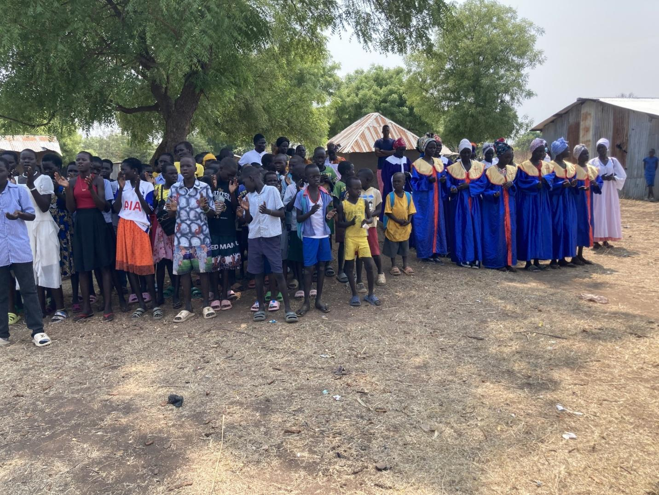
Our hosts in Pochalla were the Commissioner of Pochalla South County and the local Presbyterian church. We were graciously received by the Commissioner and the church leaders, including the church choir, when we landed on the dirt airstrip on Monday, February 17. We stayed in a compound and slept in a tukel. The compound had electricity and wi-fi during the day from a generator, so some were able to communicate with family back home (a seven-hour time difference).
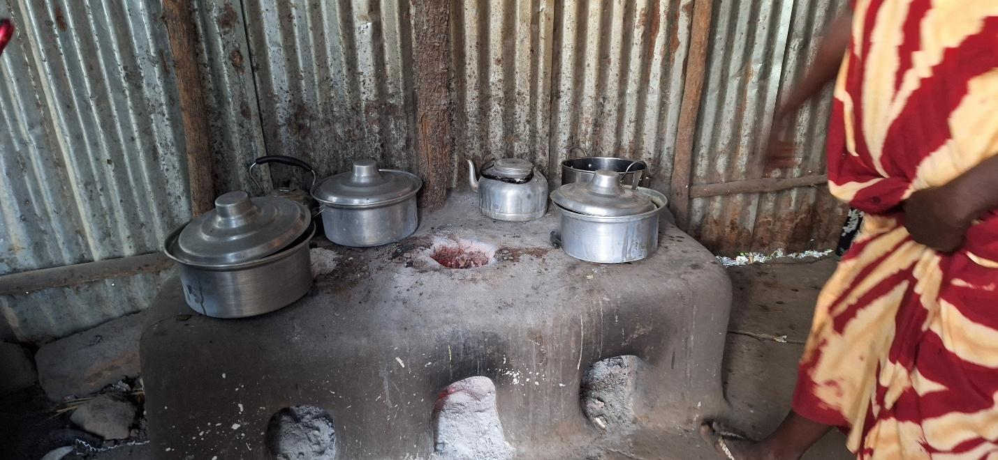
Our meals were prepared by the women of the church. Most of the food (rice, flour, lentils, salt, cooking oil) was purchased by us in Juba. Onions and antelope (white eared kob) meat were gifts of the community. All of the food was cooked over fire or wooden embers. Every meal was delicious!
Laptops
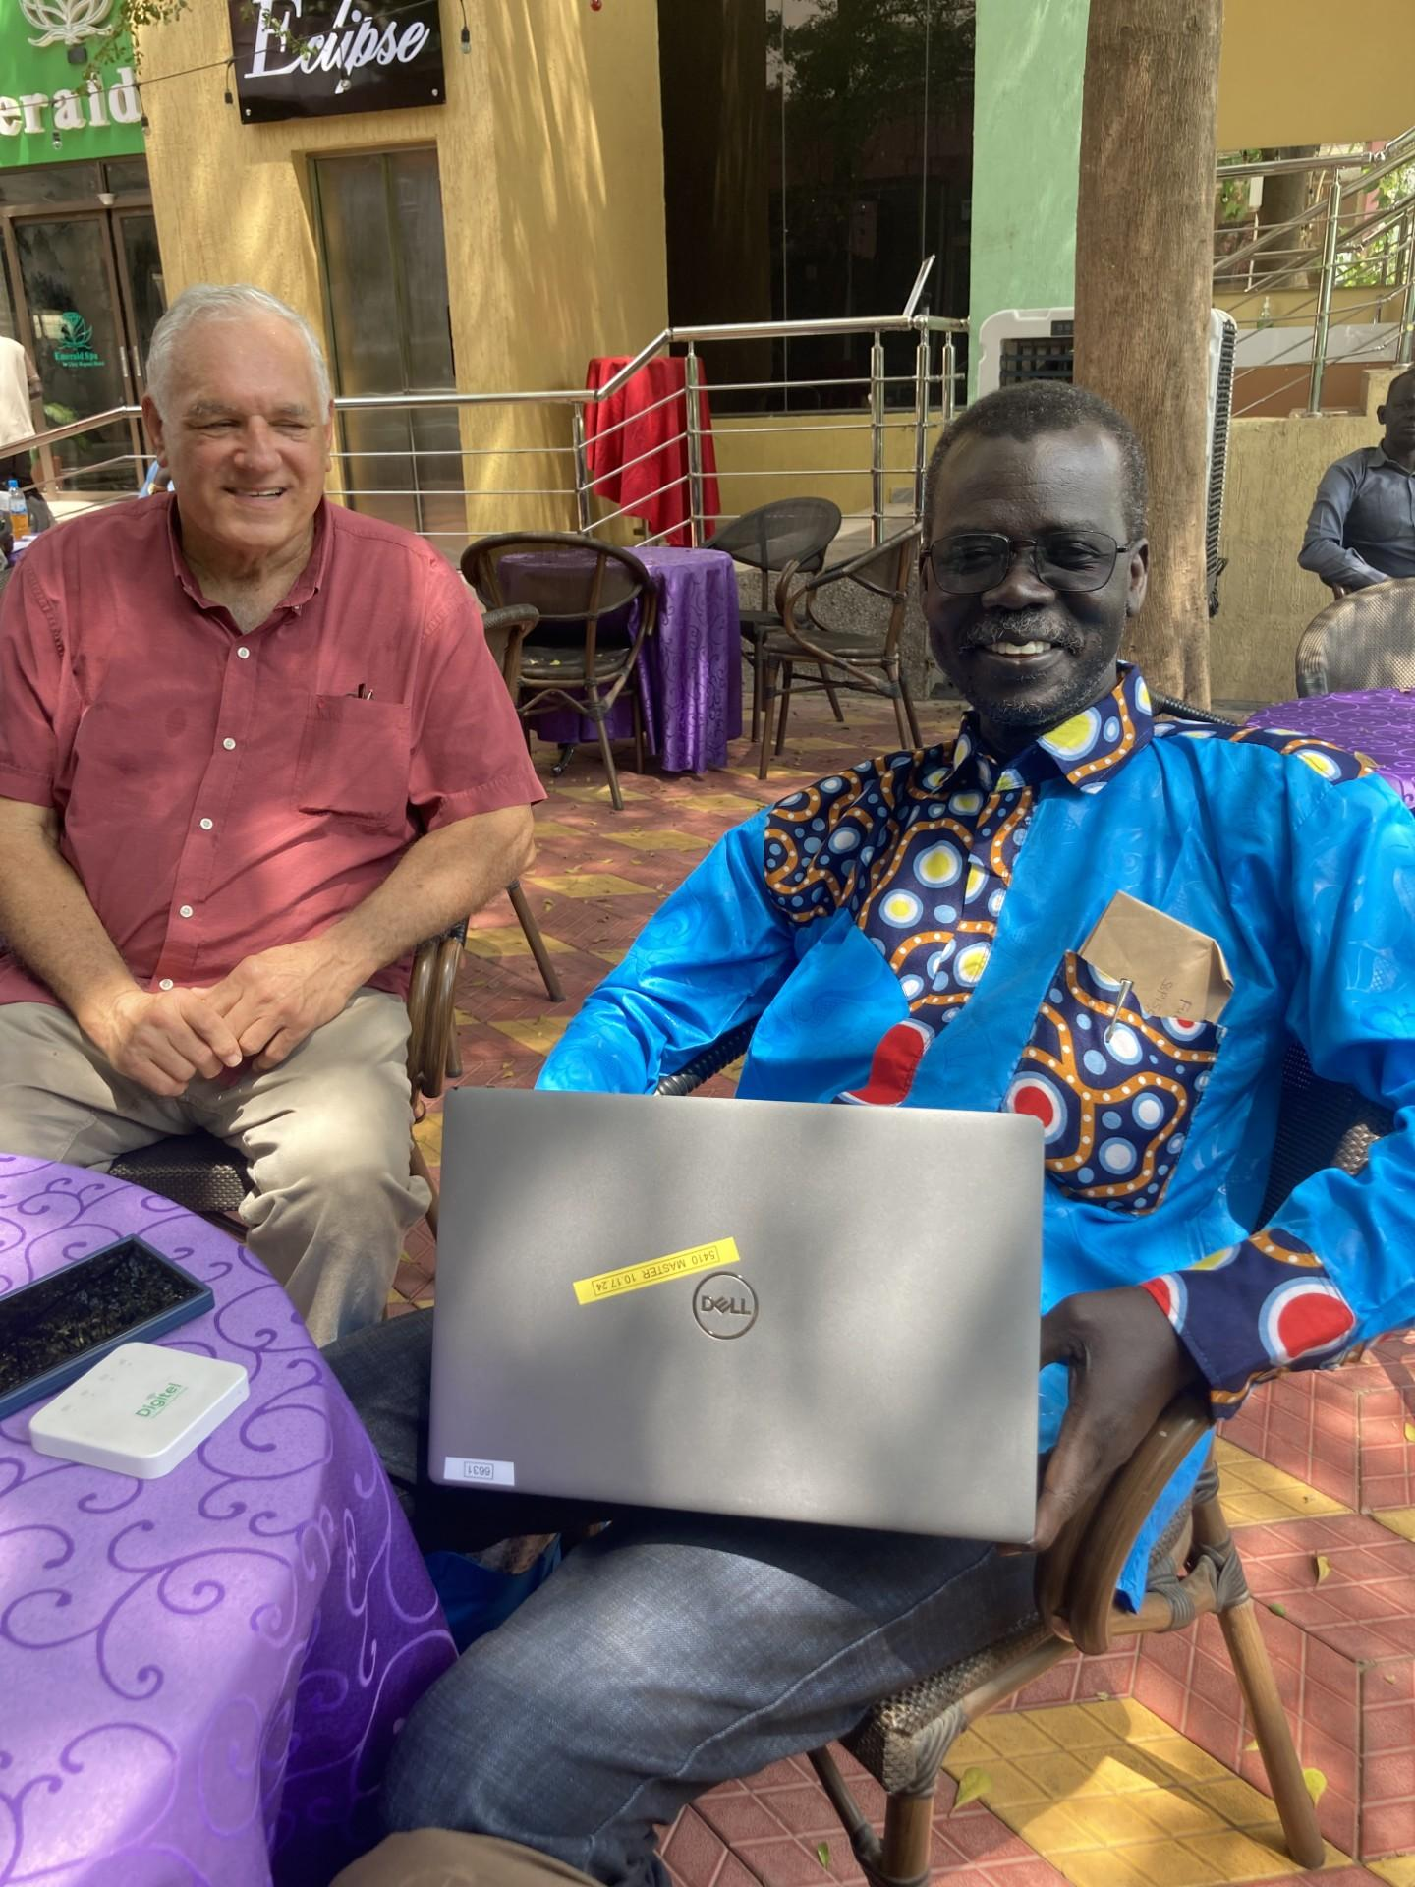
The laptops were presented to the theological college for student use.
We also met with the local pastor and the Moderator of Pibor Presbytery. Their needs are:
- more secular education (teachers are not being paid)
- financial support for seminary students
- peace among the tribal groups
- clean water.
Kindness
An interesting situation arose a couple of weeks before we arrived in Pochalla. The people of Pochalla are of the Anuak tribe, and one of the neighboring tribes are the Murle. There are frequent violent clashes between the two groups. A few weeks before we arrived, a young teenaged Murle boy became separated from his people and was lost. For three days he had no food or water. He slept in a tree at night because of lions and hyenas. One night he fell from a tree after falling asleep. On the fourth day, he was found by the Anuak. He was thirsty, and they gave him drink. He was hungry, and they gave him food. They took him into their house and gave him shelter. The Anuak contacted the UN and were arranging to have the boy taken back to his hometown of Pibor. Hopefully this “Good Samaritan-like” example of kindness can lead to peace.
Glasses
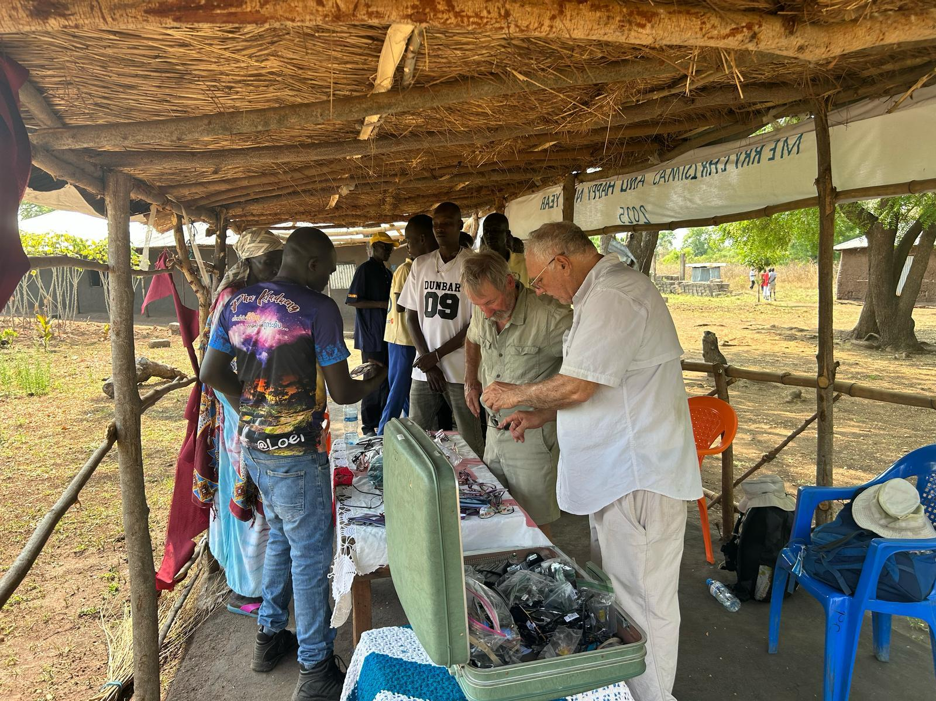
The reading glasses, donated by Lions Club, were very popular and greatly appreciated. We also gave away sunglasses, also donated by Lions Club.

Talking Bibles
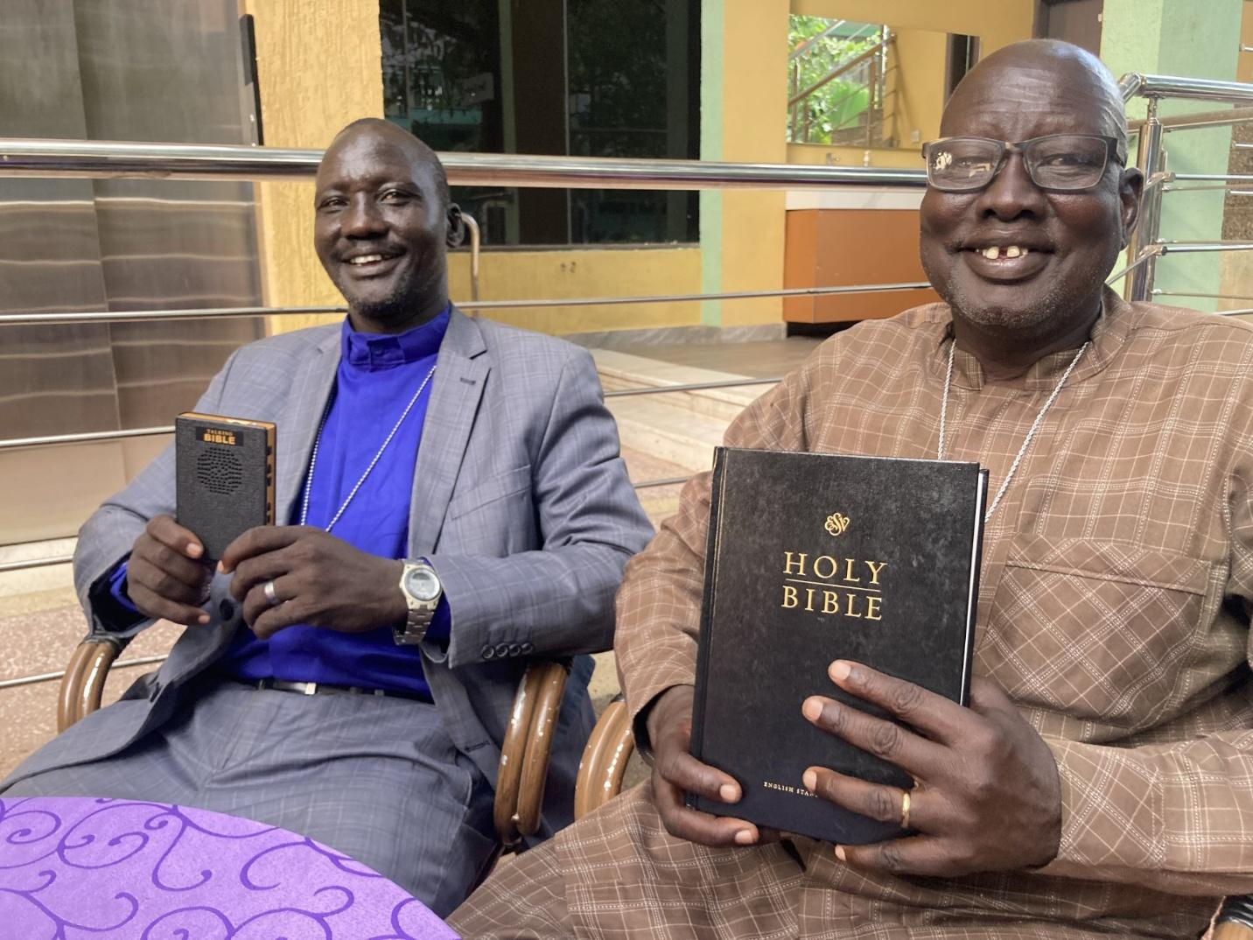
We distributed Talking Bibles (about 40 in Anuak and 10 in other languages) after showing them how to use them. They want more!
Since English is a national language, we tried something a little different this time. We paired three ESV Talking Bibles with three ESV hardcopy Bibles. A pair was given to three different men from three different ethnic groups (Anuak, Murle, and Nuer). They are to use them in small groups to help people learn both English (national language) and scripture. We will follow up to see if this pairing is worthwhile.
Hunger
Before leaving the US, we became aware of a severe hunger situation in Pochalla. It was so bad that the commissioner of Pochalla actually had shots fired between his legs by an angry and hungry soldier. Boma and Eden (partner group) wired funds to the commissioner to help with this situation.
Prayer Request
While everyone agreed that our Mission Trip was a great success, a recent turn of events has created great fear and harm. A severe cholera outbreak has engulfed the nation which has very limited ability to address it. Recent withdrawal of support greatly reduces the potential for successful medical intervention. Furthermore, recent actions by the government seem to be creating a rapid descent into another widespread civil war.
Please pray for the people of South Sudan that they may be relieved of government oppression and gain the ability to progress.
Please continue your financial and prayer support. THANK YOU.

